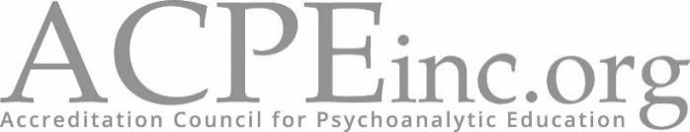
Article XI
Ethics Disclaimer Form

Please answer all the following:
- Have you had any Claims or are you aware of any circumstances that may result in a Claim arising out of your professional services (including incidents or occurrences reported to your prior carrier)?
_____ Yes _____ No
- Have you been sanctioned or are you currently under review by any professional ethics body, State licensing board or other regulatory body or ever had your license revoked or suspended?
_____ Yes _____ No
- Have you had your membership in any professional organization refused, suspended or revoked or received any official reprimand from any professional organization?
_____ Yes _____ No
- Have you had any hospital restrict, reduce or suspend your privileges or invoke probation?
_____ Yes _____ No
Professional Liability Insurance:
- Do you currently have Professional Liability Insurance?
_____ Yes _____ No
- Please provide the name of the policy:

___________________________________________________

_____________________________ __________________
Signature Date

